Sensing Fine:Grained Hand Activity with Smartwatches

【Summary】：

In this work, we explore the feasibility of sensing hand activities from commodity smart-watches, which are the most practical vehicle for achieving this vision. Our investigations started with a 50 participant, in-the-wild study, which captured hand activity labels over nearly 1000 worn hours. We then studied this data to scope our research goals and inform our technical approach. We conclude with a second, in-lab study that evaluates our classiﬁcation stack, demonstrating 95.2% accuracy across 25 hand activities. Our work highlights an underutilized, yet highly complementary contextual channel that could un-lock a wide range of promising applications.

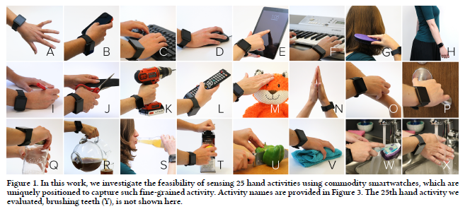

【ViBand】：

As a proof-of-concept platform, we use the smart-watch and high-speed sampling mode identiﬁed in our pre-vious ViBand [39] research. This is a LG W100 smartwatch running Android Wear (Figure 2). By modifying the pub-licly available kernel [5], it is possible to conﬁgure the built-in MPU6515 IMU to stream three-axis accelerometer data at 4kHz [30]. This data stream captures coarse hand move-ment and orientation, as well as bio-acoustic data (up to the 2kHz Nyquist limit).

【Two key issues for thesis research】：

1) What activities do humans perform with their hands in the modern world? Armed with such a list, we hoped to focus our technical eﬀorts and better understand how recognition of these activities could be valuable in a com-putationally-enhanced setting.

2) Do diﬀerent hand activities generate characteristic signals? In other words, are hand activities distinct and sep-arable? Does a commodity sensor in a smartwatch provide suﬃcient ﬁdelity to enable robust classiﬁcation?

【Experiments】：

**E1：Experience Sampling Study**

We employed an experience sampling method (ESM) [17], which reduces biases by collecting data in situ [10]. Using a ﬂeet of ten smartwatches, we deployed a cus-tom application to 50 participants over the course of two weeks. We used a participant pool drawn from the local population to cover a variety of ages, genders and profes-sions (25 female, mean age of 26.3).

**Procedure:** Omitted

**Results:** 6.2 Results

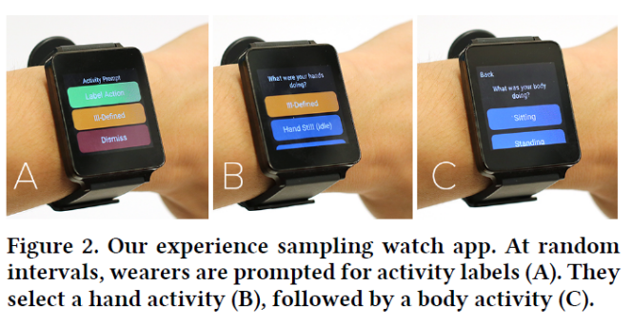

**E2：HAND ACTIVITY CLASSIFICATION**

Based on our sampling studies, we set out to establish a hand motion sensing pipeline for evaluation. This includes three key phases: sensing, signal processing, and machine learning.

**Apparatus：**samrt watch

**Practice:** including sampling, neural networks. . . (Specifically in the paper)

**Results:**

Per-User Accuracy/All-Users Accuracy

Accuracy Post-Removal

Leave-One-User-Out Accuracy (Across User)

False Positive Rejection

Sampling Frequency vs. Accuracy

【Application】: in EXAMPLE USE DOMAINS

【Conclusion】:

In 25 hand movements, 95.2% accuracy was shown, and unknown hand movements could be rejected with 86.3% accuracy. Especially because our method does not require external infrastructure or object detection.

【Important Reference】:

List in chinese version